System Design Document

Multi-Cluster High Availability Architecture with Automated Failover & Security Hardening
Date: January 04, 2025
Project Status: Active
Architecture Pattern: Active-Passive (Hot/Standby)

1. Executive Summary
This document outlines the design and implementation of a resilient, fault-tolerant infrastructure for a containerized Python/Flask application. The system leverages a multi-context Kubernetes environment to achieve an Active-Passive (Hot/Standby) failover mechanism. Traffic management is handled by HAProxy, ensuring zero-downtime operations during primary cluster failures. Furthermore, the architecture enforces a "Secure by Design" philosophy, integrating strict Network Policies, automated OS hardening via Ansible, and compliance auditing via OpenSCAP.

2. Project Specification
- Objective: To implement a robust High Availability (HA) system capable of automatic failover and self-healing.
- Workload: Containerized Python/Flask REST API.
- Infrastructure: Multi-context Kubernetes (Minikube simulating distinct clusters).
- Traffic Management: HAProxy Load Balancer.
- CI/CD: Automated pipelines via GitHub Actions on self-hosted runners.

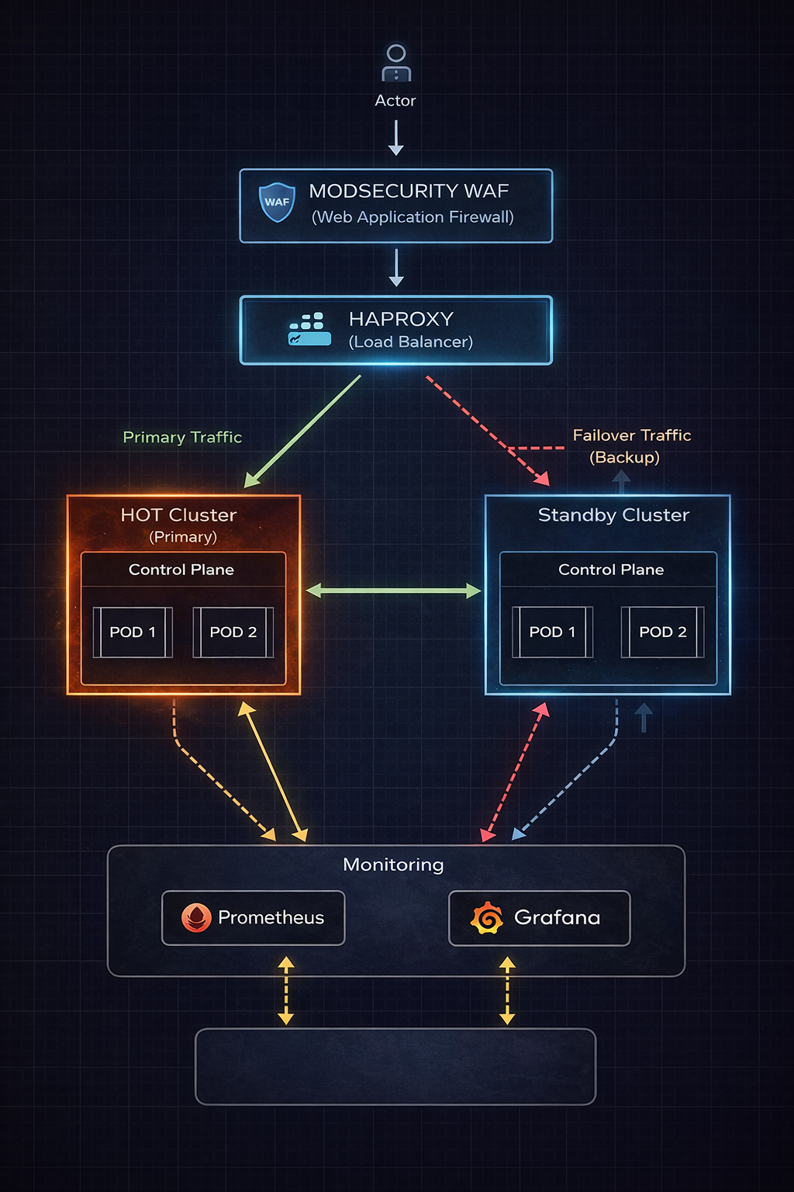

3. Component Architecture
3.1 Routing Layer (ModSecurity WAF + HAProxy)
The entry point for the system is managed by a two-tier architecture: ModSecurity WAF (Web Application Firewall) as the first line of defense, followed by HAProxy acting as a Load Balancer. The WAF is accessible locally via port 8080.

Security & Filtering:
ModSecurity WAF: Filters all incoming traffic using OWASP Core Rule Set (CRS), performs bot detection, rate limiting (10 req/s), and blocks malicious requests before they reach HAProxy.
HAProxy: Routes filtered traffic to backend clusters with health checks and automatic failover capabilities.
- Traffic Distribution Strategy:
  - Primary (Hot): Receives 100% of traffic under normal operating conditions.
  - Failover (Standby): Receives traffic only when the Primary cluster is unhealthy.
- Health Monitoring Logic:
  - Interval: Health checks are polled every 1000ms (1 second).
  - Failure Threshold: Failover is triggered after 2 consecutive failed checks, resulting in a theoretical Recovery Time Objective (RTO) of approximately 2 seconds.

3.2 Compute Layer (Kubernetes)
The application logic resides in two isolated Kubernetes contexts to simulate geographic or logical redundancy.
Cluster Name | Role | Operational State
hot-cluster | Primary | Active: Processes all live user requests.
standby-cluster | Backup | Passive: Idle/Ready state; receives traffic only during disaster recovery.

- Scalability (Horizontal Pod Autoscaler):
  - To ensure performance under load, both clusters utilize the Kubernetes Horizontal Pod Autoscaler (HPA).
  - Base Capacity: 2 Replicas.
  - Max Capacity: 5 Replicas.
  - Scaling Trigger: Replicas scale up when CPU utilization exceeds 70%.

3.3 Automation & CI/CD
Deployment consistency is managed through a GitHub Actions pipeline using a self-hosted macOS (ARM64) runner to support multi-architecture builds.
Pipeline Stages:
- Security Scan: CodeQL analysis for vulnerability detection
- Build: AMD64/ARM64 Docker images for hardware compatibility
- Deploy: Simultaneous Hot and Standby cluster deployments
- Dynamic HAProxy Update: Auto-updates ConfigMap with latest Service IPs
- Network Security: Enforces network policies across all clusters.

4. Network & Data Flow
- Request Initiation: The client sends a request to http://localhost:8080 (tunneled to the ModSecurity WAF pod).
- WAF Inspection: ModSecurity filters traffic against OWASP CRS (SQLi, XSS) and enforces a 10 req/sec rate limit.
- Traffic Tunneling: Legitimate requests are forwarded to the HAProxy pod.
- Health Validation: HAProxy performs active checks against the hot-cluster (1s interval, Fall 2/Rise 2).
- Backend Dispatch:
  - Condition A (Healthy): Traffic is routed to the hot-cluster Service.
  - Condition B (Unhealthy): Traffic is rerouted to the standby-cluster Service.
- Response: The backend returns the payload and a CLUSTER_ROLE header; the response flows back through HAProxy and WAF to the client.

5. Disaster Recovery Strategy
The system is designed to handle failure at both the granular (Pod) and macro (Cluster) levels.
- Level 1: Node/Pod Failure
  - Handled natively by Kubernetes Services and ReplicaSets. If a pod crashes, Kubernetes restarts it (maintaining 2 replicas). If load increases, HPA scales up to 5 replicas.
- Level 2: Cluster Outage
  - Handled by HAProxy. If the primary cluster's heartbeat is lost (e.g., network partition or critical failure), the "backup" directive is activated.
- Recovery (Failback):
  - Traffic automatically reverts to the Primary cluster only after it passes health checks for 3 consecutive cycles, preventing "flapping" between clusters.

6. Security Architecture & Hardening
The security posture adopts a "Defense in Depth" approach, securing the application, the network, and the underlying host.

6.1 Backend Service Isolation (Network Policies)
- Controlled access: Backend services only accept traffic from HAProxy and Prometheus all other connections are blocked.
- Network isolation: Backend pods can only communicate with kube-dns for DNS resolution; all other outbound connections are blocked to prevent data exfiltration.

6.2 Firewall Security
- Attack prevention: ModSecurity WAF blocks SQL injection, XSS, command injection, and other OWASP Top 10 attacks using 835 security rules, logging all blocked attempts for security monitoring.
- Traffic filtering: Rate limiting (10 req/sec per IP) and method restrictions ensure only legitimate traffic reaches backend services, with automatic blocking of suspicious patterns and malicious headers.

6.3 Host Security (Ansible Automation)
The underlying infrastructure is hardened using Ansible playbooks to ensure consistent security baselines:
- SSH Hardening: Password authentication is disabled. Access is restricted to SSH keys only, root login is blocked, and idle sessions are terminated after 5 minutes to prevent session hijacking.
- Automated Patching: unattended-upgrades is configured to automatically install security updates daily. Unused packages and old kernels are pruned to minimize the attack surface.

6.4 Compliance Auditing (OpenSCAP)
To validate the security posture against industry standards:
- CIS Benchmarking: An automated OpenSCAP scan runs during deployment, checking the OS against the Center for Internet Security (CIS) profile.
- Reporting: Compliance reports (HTML/XML) are generated in /tmp/ for audit trails and review.
6.5 CodeQL Security Analysis (SAST)
- Automated vulnerability detection: CodeQL performs static analysis on Python code to detect security vulnerabilities, code quality issues, and potential bugs before code reaches production.
- GitHub Security integration: All security findings are automatically uploaded to the GitHub Security tab with severity ratings and remediation recommendations for easy tracking and resolution.
- Continuous security scanning: Runs automatically on every push and pull request, providing continuous security monitoring throughout the development lifecycle.

7. Conclusion
This architecture successfully meets the requirements for a High Availability system. By combining the orchestration power of Kubernetes with the routing intelligence of HAProxy and the configuration management of Ansible, the system delivers a platform that is not only resilient to failure but also secure by default. The implementation of Horizontal Pod Autoscaling further ensures that the system remains performant under varying load conditions, making it suitable for production-grade deployments.

